**Java 11 Assignment**

1)

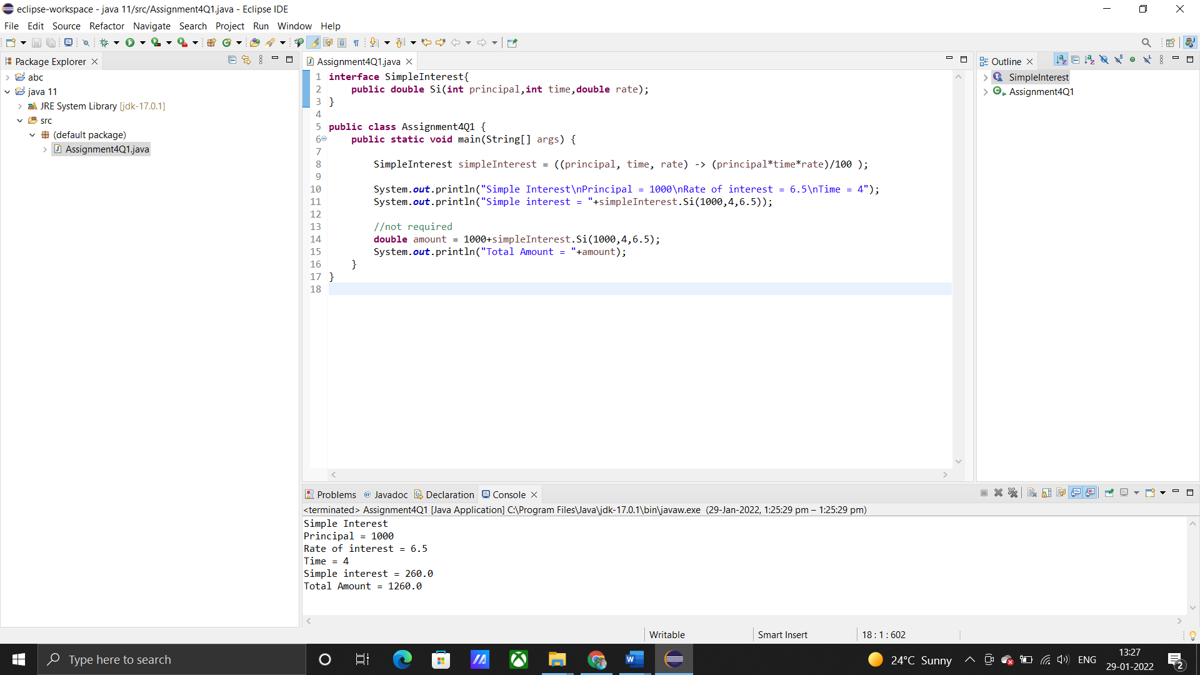

2)

* You can use var only for local variables (in methods). It cannot be used for instance variables (at class level).
* You cannot use var in Lambda expressions.
* You cannot use var for method signatures (in return types and parameters).
* And remember, you cannot use var to declare a variable without explicit initialization, hence the following:

var X;

* is not allowed, since local variable declaration requires initialization on the right side. That also means this declaration is not valid:

var X = null;

3)

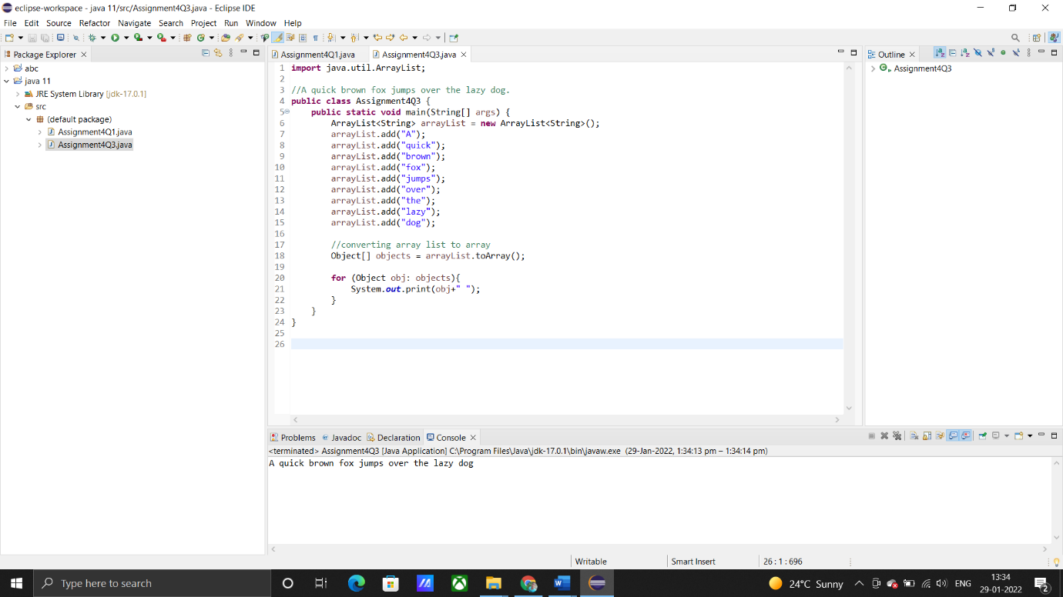

4)

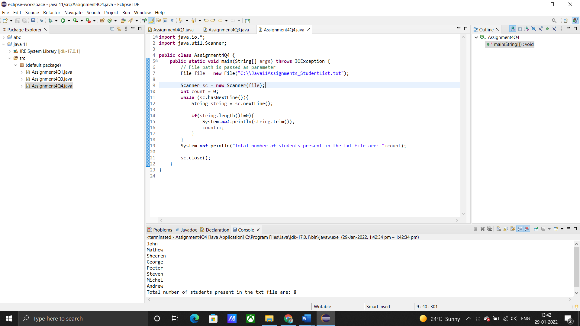

5)

